- SIX DAYS | - THREE CONFERENCES | - ONE EXHIBITION

 | EUROPE’S PREMIER MICROWAVE, RF, WIRELESS AND RADAR EVENT | 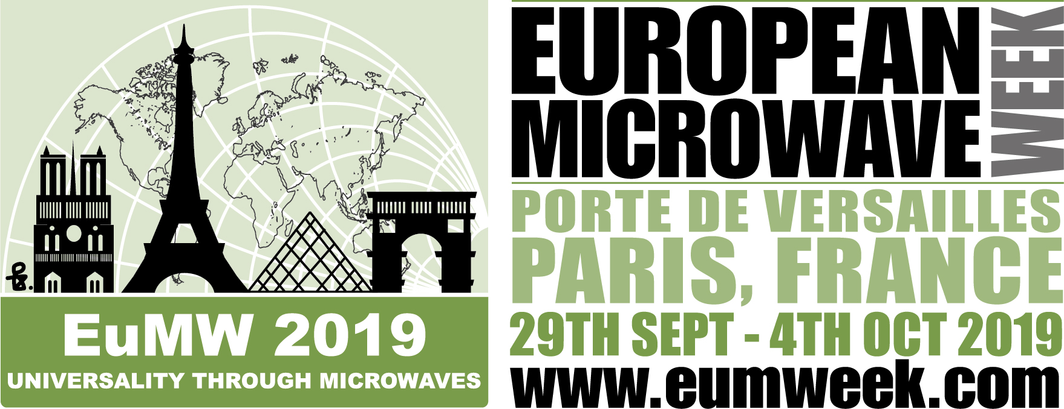

CALL FOR PAPERS
AUTOMOTIVE FORUM

European Microwave Week 2019
Paris expo Porte de Versailles
Paris, France

Monday, September 30th, 2019

The 1st Automotive Forum of the European Microwave Week

Organised by:

Submit presentation summaries online at www.eumweek.com

by 22nd MARCH 2019

to: eumw2019-automotiveforum@unilim.fr

Information
Objective of the automotive forum: To discuss technical aspects and market issues in the area of microwaves in automotive industry.
Topics for 20 minutes presentation including questions:
1. System architectures for advanced radar systems – smart sensors versus centralized systems
2. Advanced methods for radar interference suppression
3. Artificial intelligence in radar signal processing
4. Fusion of radar and camera
5. Radar-based generation of digitals maps

If you want to propose a talk for this forum, please use the template on the next page and send your short summary to:
eumw2019-automotiveforum@unilim.fr

ADDRESSES
Chair:  Thomas Zwick  Karlsruhe Institute of Technology, Germany  : thomas.zwick@kit.edu | Co-Chair:  Frank Gruson  Continental AG, Germany  : frank.gruson@continental-corporation.com | Local Arrangement Chair:  Stéphane Méric  INSA de Rennes, IETR, France  : Stephane.Meric@insa-rennes.fr
IMPORTANT DATES:
March 22nd , 2019 | Deadline for submission of summaries
April 19th, 2019 | Notification of acceptance

Template

Title of the Automotive Forum Talk

J. Clerk Maxwell^{#1}, Michael Faraday^{*#2}, André M. Ampère^{#3}
#RFIC Lab, My University, USA
*Microwave Research, Australia
{¹J.Clerk.Maxwell, ³Ampere}@my-uni.edu, ²michael@mr.com.au

Automotive Forum Talk Summary
Please use this template to generate your summary. Feel free to add graphs but not more than one single page would be appreciated. Cite: [1]:

References

- G. Eason, B. Noble, and I.N. Sneddon, “On certain integrals of Lipschitz-Hankel type involving products of Bessel functions,” Phil. Trans. Roy. Soc. London, vol. A247, pp. 529-551, April 1955. (references)

